# INVESTIGATING THE IMPACT OF VARIABLE NON-LINEAR ACTIVATION FUNCTIONS ON SKIN LESION CLASSIFICATION WITH CNN

**B. Vinod Reddy . 20951A04P4**

# INVESTIGATING THE IMPACT OF VARIABLE NONLINEAR ACTIVATION FUNCTIONS ON SKIN LESION CLASSIFICATION WITH CNN

# *A Project report*

# *Submitted in partial fulfillment of the Requirement*

# *for the award of the degree of*

## BACHELOR OF TECHNOLOGY

**IN**

## ELECTRONICS AND COMMUNICATION ENGINEERING

## BY

## B Vinod Reddy (20951A04P4)

**Under the Esteemed Guidance of**

**Ms. B LAKSHMI PRASANNA**

### (Assistant Professor)



**DEPARTMENT OF ELECTRONICS AND COMMUNICATION ENGINEERING INSTITUTE OF AERONAUTICAL ENGINEERING**

## (Autonomous)

**Dundigal, Hyderabad-500043, Telangana JAN 2024**

*©*2024, B VINOD REDDY

**All rights reserved**

**DECLARATION**

I certify that

a) The work contained in this report is original and has been done by me under the guidance of my supervisor(s).

b) The work has not been submitted to any other institute for any degree or diploma.

c) I have followed the guidelines provided by the institute in preparing the report.

d) I have confirmed to the norms and guidelines given in the Ethical Code of Conduct of the Institute.

e) Whatever I have used materials (data, theoretical analysis, figures, and text) from other sources, I have given due credit to them by citing them in the text of the report and giving their details in the references. Further, I have taken permission from the copyright owners of the sources, wherever necessary.

**Place : Hyderabad Signature of the student**

**Date : Roll Number :**

**CERTIFICATE**

# This is to certify that the project entitled INVESTIGATING THE IMPACT OF VARIABLE NON-LINEAR ACTIVATION FUNCTIONS ON SKIN LESION CLASSIFICATION WITH CNN by Mr. B VINOD REDDY (20951A04P4) to the INSTITUTE OF AERONAUTICAL ENGINEERING, Hyderabad in partial fulfillment of the requirements for the award of the Degree Bachelor of Technology in ELECTRONICS AND COMMUNICATION ENGINEERING is a bonafide record of work carried out by him under my guidance and supervision. The contents of this report, in full or in parts, have not been submitted to any other Institute for the award of any degree.

**Supervisor Head of the Department**

**Ms. B Lakshmi Prasanna Dr. P Munaswamy**

**Assistant Professor**

**Date :**

**APPROVAL SHEET**

# This project report INVESTIGATING THE IMPACT OF VARIABLE NON-LINEAR ACTIVATION FUNCTIONS ON SKIN LESION CLASSIFICATION WITH CNN is done by B VINOD REDDY (20951A04P4) is approved for the award of the Degree Bachelor of Technology in ELECTRONINCS AND COMMUNICATION ENGINEERING.

**Examiners Supervisor(s)**

**Ms. B Lakshmi Prasanna**

**Assistant Professor**

**Principal**

**Dr. L V Narasimha Prasad**

**Date:**

**Place: HYDERABAD**

**V**

**ACKNOWLEDGEMENT**

I am greatly indebted to my project guide, **Ms. B Lakshmi Prasanna**, **Assistant** **Professor**, Department of Electronics and Communication Engineering, for her valuable guidance and inspiration which have sustained me to accomplish my work successfully.

I have great pleasure in expressing my sincere thanks to **Ms. B Lakshmi Prasanna**, **Assistant** **Professor of ECE** and express our gratitude to **Dr. P MUNASWAMY, Head of the Department.** who ignited my hidden potential, built career, in calculated self-confidence, sincerity and discipline within me and gave of success.

It is my pleasure to acknowledge gratefully to the Management, and our beloved chairman

**Sri. M. Rajashekar Reddy** and principal **Dr. L V Narasimha Prasad Professor**, for their inspiration, valuable suggestions and keep interest during my work.

I am grateful to the teaching and non-teaching faculty members of the Department of Electronics and Communication Engineering, for their encouragement and the facilities provided during my project work.

I appreciate the arduous tasks of my friends, near and dear who injected patience and fortitude to overcome the challenges that have come my way.

I perceive this opportunity as a big milestone in my career development. I will strive to use gained skills and knowledge in the best possible way, and I will continue to work on their improvement, to attain desired career objectives. Hope to continue cooperation with all of you in the future.

With Gratitude*,*

B Vinod Reddy 20951A04P4

vi

# ABSTRACT

Melanoma, a dangerous type of skin cancer, can be treated successfully if caught early. Detecting it late increases the risk of death. Melanoma starts in melanocytes, the cells that make melanin, the pigment giving color to skin, hair, and eyes. It's considered one of the most severe skin cancers because it can spread to other body parts. Skin condition is crucial in spotting diseases early. This study uses advanced computer technology called convolutional neural networks (CNNs) to better identify skin lesions. By including complex processes in the analysis, the CNN adapts well to different types of skin problems. Traditional methods like Rectified Linear Unit (ReLU) are basic and struggle with complicated shapes in skin images, so new methods like Parametric Rectified Linear Unit (PReLU), Leaky ReLU, Hyperbolic Tangent and Exponential Linear Unit (ELU) are explored. The CNN learns from a vast dataset called HAM10000, which covers many skin conditions and is labeled by skin experts. We test the CNN using sensitivity, specificity, and accuracy measures to see how well it performs compared to other methods. This research aims to make skin cancer diagnosis more accurate and accessible to everyone.

**Keywords**: Convolution neural network, HAM10000, Image augmentation, Melanoma, non linear activation functions

|  |  |  |
| --- | --- | --- |
|  | **LISTOFCONTENTS** |  |
| Title Page Declaration |  | Ⅰ  Ⅲ |
| Certificate by the supervisor  Approval Sheet Acknowledgement |  | Ⅳ  Ⅴ  Ⅵ |
| Abstract |  | Ⅶ |
| List of Contents  List of Figures  List of Tables |  | VIII  Ⅹ  XI |
| List of Abbreviations |  | XII |

CHAPTER 1 INTRODUCTION 1

* 1. Introduction of skin lesion classification 1
  2. Real time Applications 1
  3. Objectives 2
  4. Overview 3

CHAPTER 2 LITERATURE SURVEY 3

2.1 Existing Solution

2.2 Proposed Solution

CHAPTER 3 METHODOLOGY 11

* 1. Block Diagram 11
  2. Libraries used 11
  3. Architecture 13

CHAPTER 4 SOFTWARE REQUIREMENT 14

* 1. Deep Neural Network 14
  2. Neural Network Model Design 14
  3. Variable Non-Linear Activation Functions 15
  4. Image Processing Libraries 15
  5. Data Management 16
  6. Model Evolution 16
  7. Development Environment 16
  8. Visualization Tools 16
  9. Documentation and Visualization 16

CHAPTER 5 RESULTS AND ANALYSIS 17-23

5.1RESULTS

CHAPTER 6 CONCLUSION &FUTURE SCOPE 24

|  |  |  |
| --- | --- | --- |
|  | 6.1 Conclusion |  |
|  | 6.2 Future scope |  |

## REFERENCES 25-26

## LIST OF FIGURES

**Figure No. Title Page No.**

* 1. Seven Types of Skin Cancer Images 2

1.2 some author with models and accuracy 6

1.3 some random images after balanced

1.4 CNN Architecture

2.2 Existing Flowchart

2.3 Common Nevus, Atypical Nevus, and Melanoma.

2.4 Benign, Nevus, and Melanoma.

2.5 Original, and 180 degree rotated Common Nevus.

2.6 Original, and 180 degree rotated Atypical Nevus.

2.7 Original, and 180 degree rotated Melanoma.

3.1 Block Diagram 11

3.2 Architecture 13

3.2 CNN Architecture output

5.2 random images after balanced 17

4.3 Non linear activation functions formula 15

5.4 Graphs (balanced and unbalanced classes) 18

5.6 Confussion matrix 21

5.5 cancer detection 19

**Lists of Tables**

**Table No. Title Page No.**

2.1some author with models and accuracy

**LIST OF ABBRIEVATIONS**

|  |  |
| --- | --- |
| **CNN** | Convolution neural network |
| **HAM** | Human Against Machine with 10000 training  images |
| **ReLU** | Rectified Linear Unit |
| **ELU** | Exponential linear unit |
| **CReLU** | Clipped ReLU |
| **LReLU** | Leaky ReLU |
| **Tanh** | Hyperbolic Tangent |
| **PReLU** | parameter ReLU |
| **TP** | True Positive |
| **TN** | True Negative |
| **FP** | False Positive |
| **FN** | False Negative |
| **SE** | Senstivity |
| **SP** | Specificity |
| **PR** | Precision |
|  |  |
|  |  |
|  |  |

# CHAPTER 1

## 1.1 INTRODUCTION

## Skin lesion classification is a critical task in dermatology, vital for diagnosing various skin conditions accurately and promptly. As technology evolves, Convolutional Neural Networks (CNNs) have emerged as potent tools for this purpose, particularly in analyzing medical images like skin lesions. These networks leverage deep learning techniques to discern intricate patterns and features within dermatological images. Integrating non-linear activation functions into CNN architectures further enhances their capabilities in capturing complex information. These functions, such as Rectified Linear Unit (ReLU), Leaky ReLU, Parametric ReLU, and Exponential Linear Unit (ELU), introduce flexibility to the decision-making process of the network. They allow the model to adapt to the diverse characteristics of skin lesions, facilitating effective learning and generalization across different types and stages of skin conditions.

## Skin lesions exhibit vast variations in appearance, making their accurate diagnosis a challenging task for traditional image processing techniques. CNNs, inspired by the human brain's visual processing capabilities, excel in image classification tasks by automatically learning hierarchical representations of features from input images. The inclusion of convolutional layers enables these networks to capture and understand complex spatial relationships within the images, which is crucial for accurate classification.

## This research endeavors to explore the synergies between CNNs and non-linear activation functions in the context of skin lesion classification. By studying the impact of different activation functions at various layers of the network, we aim to optimize the model's performance, enhance its interpretability, and overcome challenges associated with traditional approaches. Ultimately, our goal is to improve the accuracy and efficiency of skin lesion classification, thereby contributing to better healthcare outcomes for patients.

## In HAM10000(Human Against Machine with 10000 training images) a large collection of multi-source dermatoscopic images of pigmented lesions having seven types of skin diseases. They are shown in Fig 1.1.

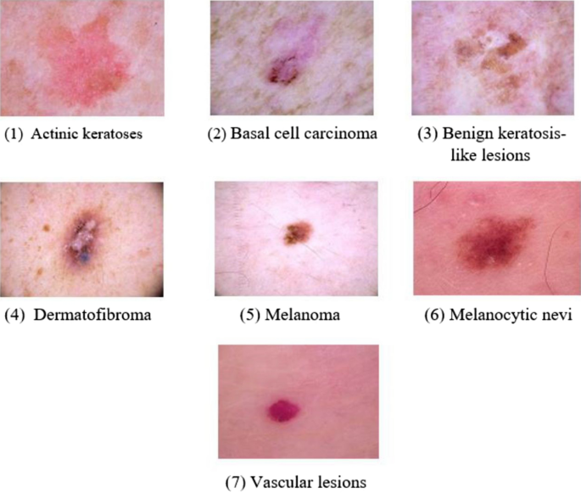

## Fig 1.1: Seven Types of Skin Cancer Images

## Where as HAM10000 dataset is unbalanced in image count and they are shown in the Fig1.2. In Fig 1.2 it is machine generated count of individual skin cancers. We use the method augmentation to balance or oversampling the images

## 

## Fig 1.2: Data Augmentation

## RANDOME IMAGES FROM DATASET:

## 

## Fig 1.3: some random images after balanced

## 1.2 Real Time Applications:

## The real-time application of Convolutional Neural Network (CNN)-based skin lesion classification using variable non-linear activation functions can have several practical use cases in the field of dermatology and healthcare. Here are some scenarios where such a system could applied

## Automated Dermatology Diagnosis:

## Provide automated and rapid skin lesion classification for dermatologists, enabling quicker and more efficient diagnosis. The system can assist healthcare professionals by quickly identifying potential malignant or benign lesions, aiding in early detection and treatment.

## Telemedicine and Remote Consultations:

## Facilitate telemedicine applications by allowing patients to capture images of their skin lesions using smartphones or dedicated devices. The CNN model, with variable non-linear activation functions, can analyze these images in real-time, providing preliminary assessments for remote consultations.

## Dermoscopy Assistance:

## Support dermatoscopists in analyzing dermoscopic images, which are magnified and illuminated images of skin lesions. The CNN model can assist in recognizing patterns indicative of different skin conditions, contributing to accurate diagnosis.

## Skin Cancer Screening Clinics:

## Implement the system in screening clinics for early detection of skin cancer. Patients can undergo a quick imaging session, and the CNN model can rapidly classify lesions, aiding in prioritizing patients who may require further examination.

## Mobile Applications for Self-Examination:

## Develop mobile applications that allow individuals to conduct self-examinations by taking pictures of their skin lesions. The CNN model can then provide instant feedback on the likelihood of the lesion being benign or malignant, encouraging users to seek professional medical advice.

## 1.3 Objectives:

## Objective 1: Improve Classification Accuracy

## Objective 2: Explore Variable Non-Linear Activation Functions

## Objective 3: Optimize Model Generalization

## Objective 4: Enhance Model Robustness

## Objective 5: Facilitate Interpretability

## Objective 6: Adaptability to Variable Activation Functions

Objective 7**:** Mitigate Overfitting

## Objective8: Contribute to Clinical Decision Support

**1.4 Overview**

A Deep Learning-based approach for Convolution Neural Network based Skin Lesion Classification with Variable non linear Activation Functions involves the use of advanced Convolution neural network architectures to automatically identify and delineate skin cancer from HAM10000 Dataset. This process is crucial for various applications, including disease diagnosis, treatment planning, and medical research. Here's an overview of the key components and steps involved in such an approach:

**1. Data Collection and Preprocessing:**

Dataset Compilation: Gather a diverse and representative dataset of skin lesion

Data Augmentation: Apply techniques such as rotation, flipping, and scaling to augment the

dataset and enhance model robustness. As shown in Fig 1.3.

**2. Model Architecture:**

Convolutional Neural Networks (CNNs): Utilize deep learning architectures, especially CNNs,

known for their effectiveness in image-related tasks. As shown in Fig 1.3.

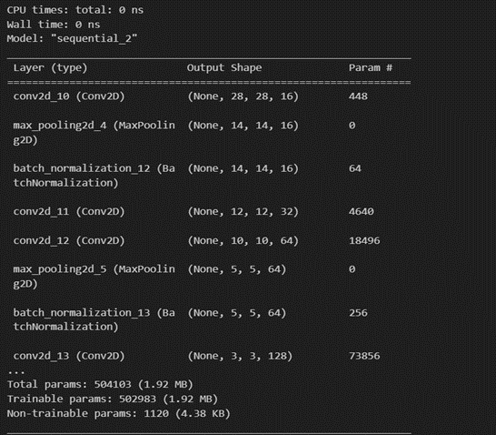v

**Fig 1.4: CNN Architecture**

**3. Training:**

Loss Functions: Employ appropriate loss functions, such as binary cross-entropy or a

combination with Dice loss, to guide the model during training.

Optimization: Use optimization algorithms like Adam to minimize the loss function and

adjust model parameters.

**4. Validation and Testing:**

Cross-Validation: Evaluate the model's performance using cross-validation techniques to ensure

generalizability.

Testing: Assess the model on an independent test set to validate its effectiveness in skin detection accurately.

# CHAPTER 2 LITERATURE SURVEY

# “The increasing incidence of cutaneous melanoma among Caucasian populations worldwide ”(2021) by Peter Murchie and Neil C. Campbell The authors of the article, Peter Murchie and Neil C. Campbell, discuss the increasing incidence of cutaneous melanoma among Caucasian populations worldwide. They argue that melanoma provides unique opportunities and challenges to primary care in terms of education and primary prevention, diagnosis, primary treatment, and aftercare1. The authors also suggest that organizational changes are required to meet the increasing challenge posed to primary care by melanoma and should be based on the most rigorous evidence.

# “The staging system for cutaneous melanoma based on data from an expanded American Joint Committee on Cancer (AJCC) Melanoma Staging Database1”(2019) by Balch CM, Gershenwald JE, Soong SJ, et al. The report aimed to revise the staging system for cutaneous melanoma based on data from an expanded American Joint Committee on Cancer (AJCC) Melanoma Staging Database1. The melanoma staging recommendations were made on the basis of a multivariate analysis of 30,946 patients with stages I, II, and III melanoma and 7,972 patients with stage IV melanoma to revise and clarify TNM classifications and stage grouping criteria1. The revisions were made using an evidence-based approach and reflect our improved understanding of this disease1. These revisions were formally incorporated into the seventh edition (2009) of the AJCC Cancer Staging Manual and implemented by early 2010.

# “Skin Lesion Classification Using Convolutional Neural Network for Melanoma Recognition”(2020) by Mohamad Li et al This article proposes a framework for skin lesion classification using CNNs. The framework uses image augmentation, transfer learning, and a novel loss function to achieve high accuracy for melanoma recognition. The authors evaluated their framework on the ISIC 2017 skin lesion dataset, and they achieved an average AUC of 87 for melanoma recognition.

# “To classify melanomas versus benign nevi using only 399 images from a standard camera.”(20180 by pomponiu et ai The model uses a variable nonlinear activation function, namely ELU, to learn discriminative features from the skin lesion images.

# “A machine learning model that uses convolutional neural networks (CNN) to classify skin lesions into various cancerous or non-cancerous skin conditions. The model is trained on the HAM10000 dataset “ (2018) by Mohapatra at al. which is a large collection of multi-source dermatoscopic images of common pigmented skin lesions. The authors suggest that incorporating this model into an online platform will enable doctors and laboratory technologists to know the three highest probability diagnoses for a given skin lesion, thereby facilitating early diagnosis of skin cancer. The authors also highlight that skin cancer is a serious threat to mankind, with the incidence of skin cancers increasing at an alarming rate over the past decades. The article provides a detailed account of the proposed solution and its potential benefits.

# “Reducing mortality and morbidity of cutaneous melanoma: A six-year plan” was published in the Journal of Dermatology in (2017). The article discusses the authors’ plan to reduce the mortality and morbidity of cutaneous melanoma over a six-year period. The authors identify high and low risk pigmented lesions using epiluminescence microscopy1. Unfortunately, I could not find more information about this article.

# “Skin cancer classification using convolution neural networks” and was published in the book “Lecture Notes in Networks and Systems” by Springer in 20201. The authors of the article are S. Mohapatra, N.V.S. Abhishek, D. Bardhan, A.A. Ghosh, and S. Mohanty1. The article discusses the use of convolutional neural networks to detect and classify skin cancer based on historical data of clinical images1. The authors aim to build a CNN model to detect skin cancer with an accuracy of >80%, to keep the false negativity rate in the prediction to below 10%, to reach the precision of above 80% and do visualization on their data1. The proposed method has shown superiority towards other compared methods1.

# “Diagnostic accuracy of dermatoscopy for melanocytic and nonmelanocytic pigmented lesions.”(2017) Rosendahl, C., Tschandl, P., Cameron, A. & Kittler The authors have used various feature extraction methods to extract meaningful features from the images, based on shape properties, color variation, and texture analysis. They have used several color spaces for the extraction of both color- and texture-related features. The developed skin lesion computational diagnosis system was applied to a set of 1104 dermoscopic images using a cross-validation procedure. The best results were obtained by an optimum-path forest classifier with very promising results. The proposed system achieved an accuracy of 92.3%, sensitivity of 87.5% and specificity of 97.1% when the full set of features was used. Furthermore, it achieved an accuracy of 91.6%, sensitivity of 87% and specificity of 96.2%, when 50 features were selected using a correlation-based feature selection algorithm .

# “A machine learning approach to classify melanocytic lesions as malignant or benign, using thermoscopic images.”(2015) The authors use a combination of features such as border, texture, color, and structures to classify the lesions . The proposed approach is based on a support vector machine (SVM) classifier. The authors report an accuracy of 88.5% in classifying melanocytic lesions as malignant or benign 1. The dataset used in this study consists of 433 benign lesions and 80 malignant melanoma. The authors suggest that their approach can be used as a combined tool to assist dermatologists in melanoma detection from dermoscopic images of pigmented skin lesions .

# “A machine learning approach to classify melanocytic lesions in malignant and benign from dermatoscopic images.”(2015) Mohapatra, S.; Abhishek, N.V.S.; Bardhan, The image database is composed of 433 benign lesions and 80 malignant melanoma. The proposed method involves automatic border detection to separate the lesion from the background skin, extraction of shape features from the border, and extraction of color and texture-related features from the image. The feature data is fed into an optimization framework, which ranks the features using various feature selection algorithms and determines the optimal feature subset size according to the area under the ROC curve measure obtained from support vector machine classification. The issue of class imbalance is addressed using various sampling strategies, and the classifier generalization error is estimated using Monte Carlo cross-validation. The experiments on a set of 564 images yielded a specificity of 92.34% and a sensitivity of 93.33% .

**Table 2.1**: some author with models and accuracy

|  |  |  |  |  |  |  |  |
| --- | --- | --- | --- | --- | --- | --- | --- |
| authors | year | model | Activation functiomin hidden layers | No.of datasets | No.of training images | SE% | AC% |
| S.Kadry | 2022 | VCCGG-segnet | ReLU | 1 | 1,250 | 95 | 96 |
| Khan | 2021 | CNN | ReLU | 1 | 10015 | 92 | 95 |
| YU | 2017 | FCRN | CReLU | 1 | 1250 | 90 | 91 |
| Khan | 2021 | DenseNet | ReLU | 3 | 14,044 | 96 | 96 |
| Polap | 2019 | CNN | TANH | 2 | 273 | 81 | 82 |
| Mabbod | 2019 | CNN | ReLU | 2 | 2187 | 91 | 91 |
| Harangi | 2018 | CNN | PReLU | 1 | 14300 | 56 | 87 |

**2.1 EXISTING SOLUTION:**

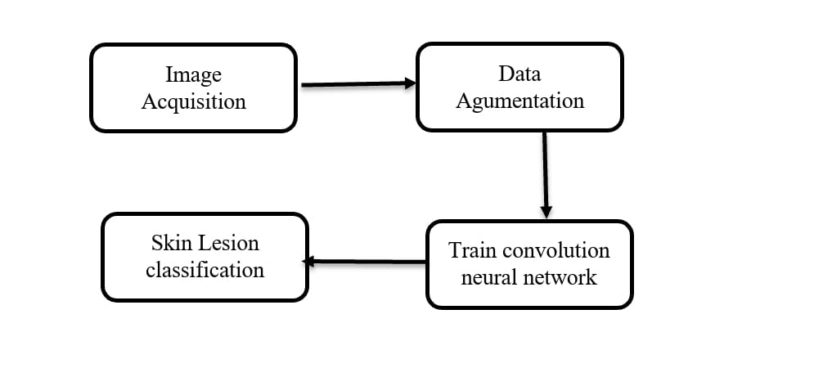

**Fig2.2:** Existing Flowchart

### Image Acquisition

The training data for a deep CNN lesion classifier that consists of 10015 high-resolution images with various types of skin diseases were downloaded from the HAM10000 database: a joint research collaboration between the Universidade do Porto, Instituto Superior Tecnico Lisboa, and the Dermatology Service of Hospital Pedro Hispano in Matosinhos, Portugal. All images were acquired under the same environment through the Tuebinger Mole Analyzer process by magnifying 20 times. The image data is divided into three classes: Atypical Nevus, Common Nevus, and Melanoma as presented in Fig. 3; which are 8-bit RGB images with 768 × 560 pixels resolution.

[[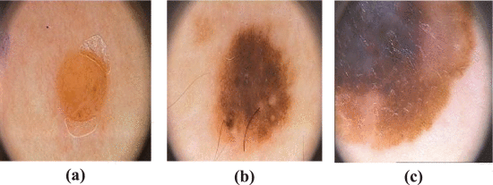](https://ieeexplore.ieee.org/mediastore_new/IEEE/content/media/6287639/9668973/9851634/obaid3abc-3196911-large.gif)](https://ieeexplore.ieee.org/mediastore_new/IEEE/content/media/6287639/9668973/9851634/obaid3abc-3196911-large.gif)

**Fig 2.3.** (a) Common Nevus, (b) Atypical Nevus, and (c) Melanoma.

[[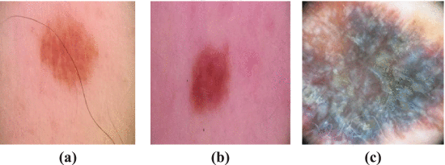](https://ieeexplore.ieee.org/mediastore_new/IEEE/content/media/6287639/9668973/9851634/obaid4abc-3196911-large.gif)](https://ieeexplore.ieee.org/mediastore_new/IEEE/content/media/6287639/9668973/9851634/obaid4abc-3196911-large.gif)

**Fig 2.4.** (a) Benign, (b) Nevus, and (c) Melanoma.

### Data Augmentation

Since the HAM10000 dataset contains only 10015 images with seven classes-1257 Melanoma, 5648 Common Nevus, and 2475 Atypical Nevus, the proposed CNN model’s training accuracy did not achieve a significant score. Therefore, the Common Nevus and Atypical Nevus images were rotated into 180 degrees to increase the number of training data in both classes from 80 to 160 respectively. Then, the Melanoma images were also rotated to 180 degrees to increase from 40 to 80 images.Finally, the rotated 10015 new images of three classes were added in the PH2 dataset to create the augmented HAM10000 dataset which gave us a total of 400 images. Since one of our research goals is to train the CNN with a minimum number of images, we only use these rotation techniques in the augmentation process. In Fig. 2.5, (a) and (b) represent for Common Nevus; in Fig. 2.6, (a) and (b) represent for Atypical Nevus; and in Fig. 2.7, (a) and (b) represent for Melanoma original images and augmented images respectively.

[[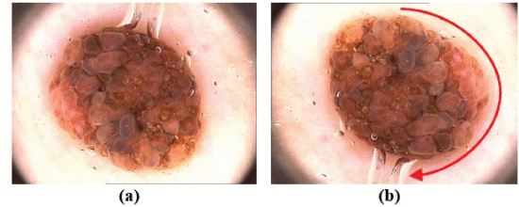](https://ieeexplore.ieee.org/mediastore_new/IEEE/content/media/6287639/9668973/9851634/obaid5ab-3196911-large.gif)](https://ieeexplore.ieee.org/mediastore_new/IEEE/content/media/6287639/9668973/9851634/obaid5ab-3196911-large.gif)

**Fig2.5.** (a) Original, and (b) 180 degree rotated Common Nevus.

[Show All](https://ieeexplore.ieee.org/document/9851634/figures)

[[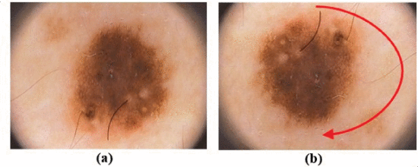](https://ieeexplore.ieee.org/mediastore_new/IEEE/content/media/6287639/9668973/9851634/obaid6ab-3196911-large.gif)](https://ieeexplore.ieee.org/mediastore_new/IEEE/content/media/6287639/9668973/9851634/obaid6ab-3196911-large.gif)

**Fig2.6.** (a) Original, and (b) 180 degree rotated Atypical Nevus.

[[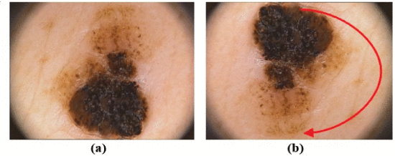](https://ieeexplore.ieee.org/mediastore_new/IEEE/content/media/6287639/9668973/9851634/obaid7ab-3196911-large.gif)](https://ieeexplore.ieee.org/mediastore_new/IEEE/content/media/6287639/9668973/9851634/obaid7ab-3196911-large.gif)

**Fig 2.7.** (a) Original, and (b) 180 degree rotated Melanoma.

### Existing Convolutional Neural Network

The diagram in Fig. 8 presents all major steps from image preprocessing to features extraction and skin lesion classification. The proposed CNN design starts with the basic concept of deep neural network design which contains 2D convolution, batch normalization, activation function and max-pooling layers. Several fundamental ideas are borrowed from the LeNet [66], which was created for hand-written digits recognition. The proposed design starts with 3 convolutional layers, 2 pooling layers and 3 fully-connected layers which provide below expected result. Also, other parameters such as stride, dilation factor, maxepochs, convolutional filter and max-pooling filter are changed multiple times to find the best combination of parameters for the proposed model. Several testing and training processes are accomplished to fix the value of these hyperparameters so that they will remain similar when different activation functions are tested during the experiment stage.

**2.2 PROPOSED SOLUTION:**

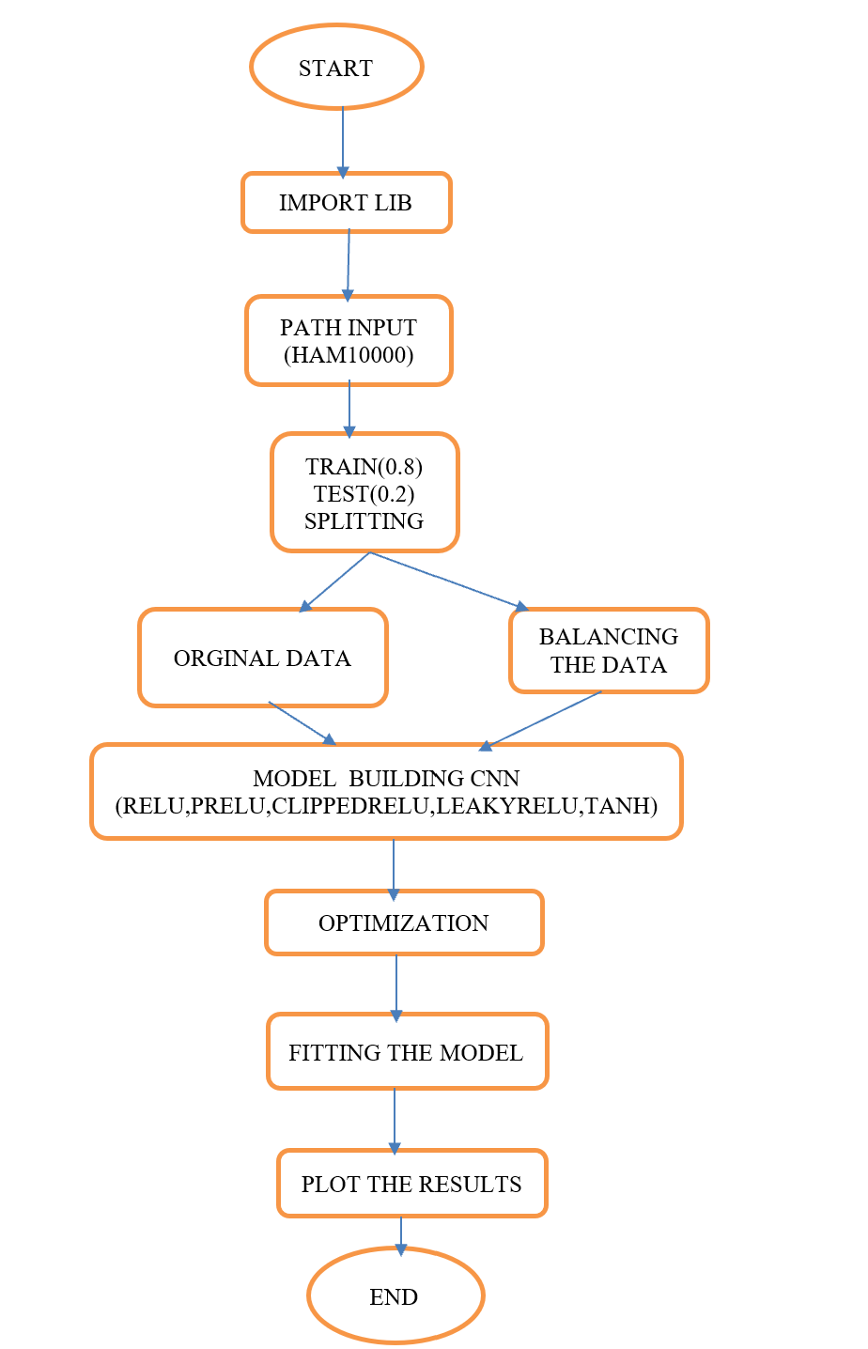This flow chart is depicting the implementation Creating a flowchart for a Convolutional Neural

Network (CNN) based skin lesion classification with variable non-linear activation functions. Thus the process begins.

Fig: 2.8 proposed flowchart (Algorithm)

# 

# CHAPTER 3 METHODOLOGY

# 3.1 PROPOSED BLOCK DAIGRAM:

This Block Daigram is depicting the implementation Creating a flowchart for a Convolutional Neural

Network (CNN) based skin lesion classification with variable non-linear activation functions. Thus the process begins.

Input data

Preprocessing

Features extraction

CNN model

classification

Fig: 3.1 Block Diagram

**3.2 LIBRARIES USED:**

When developing a skin cancer detection model using deep learning, several popular libraries and frameworks can be used to streamline the process. Here are some commonly used libraries in the context of skin cancer detection:

**NumPy:** NumPy is a fundamental package for scientific computing in Python. It provides support for

large, multi-dimensional arrays and matrices, making it essential fordata manipulation and

numerical operations.

**Tensor flow:** TensorFlow is an open-source deep learning library developed by Google. Itprovides tools for

building and training neural network models, making it widelyused in the deep learning

community.

**Pandas:** Pandas is a data manipulation library in Python that is commonly used for handling andanalyzing structured data. It can be useful for managing datasets andpreparing data for training.

**Matplotlib and seaborn:** Matplotlib and Seaborn are visualization libraries in Python. They can be used for plottinggraphs and visualizing the performance of the model, such as ROCcurves, confusion matrices,

and training/validation curves.

**Pillow:** Pillow is a fork of the Python Imaging Library (PIL) and is used for image processing tasks. It

can be useful for loading, manipulating, and saving image data.

**Open CV:** OpenCV (Open Source Computer Vision Library) is a powerful computer vision library thatcan be used for image processing and analysis. It is often used forimage preprocessing andaugmentations in skin cancer detection tasks.

**Keras:** Keras is an open-source high-level neural networks API written in Python andcapable Of running on top of TensorFlow. It provides a user-friendly interface for building and training

deep learning models.

**Pytorch:** PyTorch is another popular open-source deep learning library. It is known for its dynamiccomputation graph and is widely used in both research and industry for building neural network models.

**Scikit-learn:** scikit-learn is a machine learning library in Python that provides simple andefficient tools for **d**ata analysis and modeling, including tools for datapreprocessing, model evaluation, andhyperparameter tuning.

These libraries, combined with deep learning frameworks and tools, offer a comprehensive set

of resources for developing and deploying skin cancer detection models. It's common for

developers to use a combination of these libraries based on their preferences and the specific

requirements of this project

**3.3 ARCHITECTURE:**

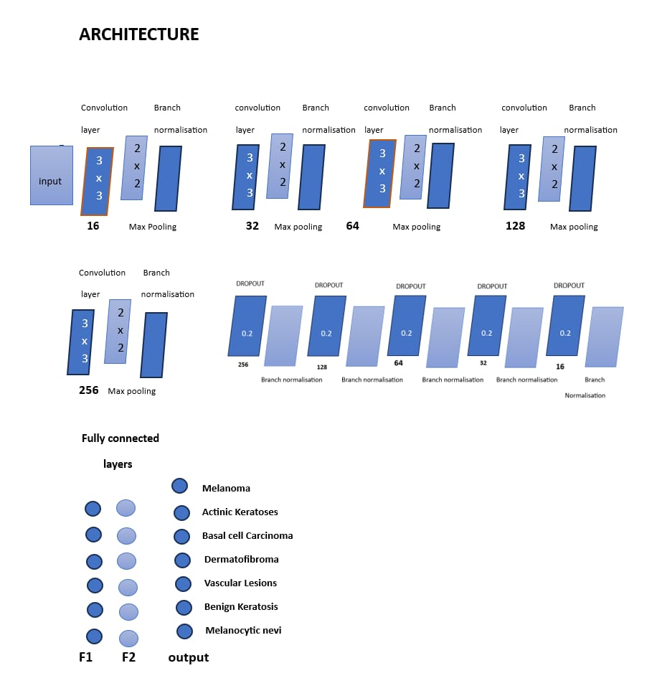

**Fig3.2: Architecture**

Architecture as shown in fig 3.2 we have convolution layers with 3x3, Batch normalization, Max pooling with width of 3x3 and finally we have fully connected layer which can connect responses to predict the type of cancer. Where as in fig 3.4 it is machine generated output while running the CNN Architecture.

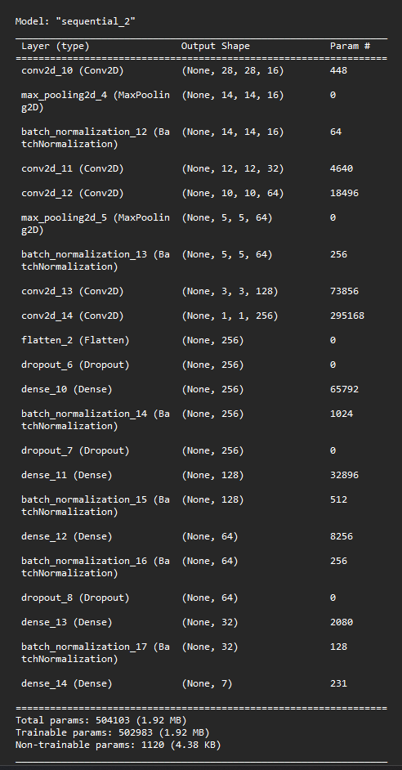

**Fig 3.3:** Output of CNN Architectre

# 

# 

# CHAPTER 4

# SOFTWARE REQUIREMENTS

# To achieve the mentioned objectives for improving the accuracy adaptability, early detection, reduced false positives/negatives, robustness, real-time classification, integration, interpretability, scalability, and generalization in a Convolutional Neural Network (CNN)-based skin lesion classification system, the following software requirements are crucial:

# 4.1 Deep Learning Framework:

# TensorFlow: TensorFlow is an open-source machine learning framework developed by the Google Brain team. It is designed to facilitate the development and deployment of machine learning models, particularly deep learning models. TensorFlow is widely used for a variety of applications, ranging from image and speech recognition to natural language processing and reinforcement learning

# 4.2 Neural Network Model Design:

# Keras: As a high-level neural networks API, Keras provides an interface for building and training models. It is often used in conjunction with TensorFlow as a backend.

# 4.3 Variable Nonlinear Activation Functions:

# Custom Activation Functions or TensorFlow/PyTorch Extensions: Depending on the framework, you may need to implement or use extensions to incorporate variable nonlinear activation functions. These could include adaptive activation functions like Parametric Rectified Linear Unit (PReLU) or Exponential Linear Unit (ELU).

# Non-linear Activation Function:

# A nonlinear neural network is a neural network that uses nonlinear transformations in its layers, such as activation functions, convolution, or pooling. An activation function is a function that adds nonlinearity to the output of a neuron, such as a sigmoid, tanh, or relu function.

# Purpose of Non-Linear activation functions:

# The non-linear functions are known to be the most used activation functions. It makes it easy for a neural network model to adapt with a variety of data and to differentiate between the outcomes.

# They allow backpropagation because now the derivative function would be related to the input, and it's possible to go back and understand which weights in the input neurons can provide a better prediction.

# 1.Relu:

# The ReLU (rectified non-linear activation function) activation function is used to introduce nonlinearity in a neural network, helping mitigate the vanishing gradient problem during machine learning model training and enabling neural networks to learn more complex relationships in data.

# This is the most commonly used activation function in CNNs. It returns 0 if it receives any negative input, but for any positive value x, it returns that value back. Hence, it can be written as f(x) = max(0, x). In the hidden layers, ReLU is effective in converting linear combinations of inputs into non-linear outputs, which can help to capture more complex relationships. However, in the output layer, we need to ensure that the predicted values are in a specific range.

# 2.Leaky ReLu:

# Leaky Rectified Linear Unit, or Leaky ReLU, is a type of activation function based on a ReLU, but it has a small slope for negative values instead of a flat slope. The slope coefficient is determined before training, i.e. it is not learnt during training. Leaky ReLU is an activation function that solves the "Dead Neuron" problem in neural networks by allowing a small negative slope for negative input values. Leaky ReLU is an activation function used in convolutional neural networks to filter extracted features, particularly in handwritten character recognition Leaky ReLU is an extension of the ReLU activation function. It is similar to ReLU, but instead of returning zero for negative inputs, it returns a small negative value. This helps to avoid the "dying ReLU" problem, where some neurons can become permanently inactive during training.

# f(x) = max(ax, x)

# where: a is small constant typically set value like 0.01

# x is the input to the neuron

# 3.Parametric Relu:

# what is the purpose of parametric method?

# Parametric statistical procedures rely on assumptions about the shape of the distribution (i.e., assume a normal distribution) in the underlying population and about the form or parameters (i.e., means and standard deviations) of the assumed distribution.

# Parametric ReLU (PReLU) is an advanced variation of the traditional ReLU and Leaky ReLU activation functions, designed to further optimize neural network performance. PReLU improves upon Leaky ReLU by making the slope a learnable parameter, enhancing model accuracy and convergence. Using Parametric ReLU does not burden the learning of the neural network. This is because the number of extra parameters to learn is equal to the number of channels. This is relatively small compared to the number of weights the model needs to learn.

# Parametric ReLU (PReLU) is an advanced variation of the traditional ReLU and Leaky ReLU activation functions, designed to further optimize neural network performance. PReLU improves upon Leaky ReLU by making the slope a learnable parameter, enhancing model accuracy and convergence.

# f(x) = ax for x<0

# x for x>=0

# It does not have zero slope parts it speeds up training

# Where: a is small constant typically set value like 0.01

# x is the input to the neuron

# 4. hyperbolic tangent:

# Hyperbolic tangent (TanH) is a non linear activation function with its center at zero and its value ranging between -1 to 1, A mathematical function commonly used in artificial neural networks for their hidden layers

# F(x)=tanh(x)=(2/1+e-2x)-1

# 5. ELU:

# The Exponential Linear Unit (ELU) is an activation function commonly used in neural networks. It's designed to capture both the benefits of Rectified Linear Units (ReLU) and smooth activation functions like the hyperbolic tangent (tanh).

# For values of x greater than zero, elu returns x unchanged.

# For values of x less than or equal to zero, it applies the ELU formula using the exponential function and the α parameter to produce the output.

# OPTIMIZER:

# SoftMax:

# SoftMax function is also known as softargmax or normalized exponential function, which converts a vector of k real numbers into a probability distribution of K possible outcomes. SoftMax function also logits value into probabilities by tacking the exponents of each output and then normalizing each number by the sum of those exponents so that the entire output vector adds up to one.

# 

**SoftMax (Zj) $=\frac{e^{Z}j}{\sum_{k=1}^{K}{e^{Z}K}}$** for j=1,2,…., k

# 4.4 Image Processing Libraries:

# OpenCV: Essential for preprocessing dermoscopic images, OpenCV provides tools for image manipulation, filtering, and feature extraction.

# 4.5 Data Management:

# Pandas: A Python library for data manipulation that is useful for handling datasets and organizing input data for training.

# 4.6 Model Evaluation:

# Scikit-learn: Use Scikit-learn for model evaluation, including metrics like precision, recall, and accuracy.

# 4.7 Development Environment:

# Jupyter Notebooks: Use Jupyter Notebooks for interactive development, experimentation, and documentation.

# 4.8 Version Control:

# Git: Employ Git for version control, collaboration, and tracking changes in your codebase.

# 4.9 Visualization Tools:

# Matplotlib or Seaborn: These libraries help visualize model performance, training curves, and other relevant metrics.

# 4.10 Documentation and Collaboration:

# GitHub or GitLab: Use a version control repository platform for collaborative development, code sharing, and documentation.

# Ensure compatibility and stability across these software components, and consider creating a virtual environment to manage dependencies. Additionally, adhere to best practices for code organization and documentation to facilitate collaboration and future maintenance.

## 

## CHAPTER 5

## RESULTS AND ANALYSIS

## 5.1 GRAPHS(WITH BALANCED AND UNBALANCED):

## 

## Fig 5.1: Activation Function ReLU

## Rectified Linear Unit (ReLU) is one of the Non-linear Activation Functions. The above Fig 5.1 represents the Rectified Linear Unit (ReLU) outputs when we train the model with balanced HAM10000 dataset and without balanced or original dataset. From fig 5.1 left side we have trained the model with balanced HAM10000 with 30 epochs for both model loss and model accuracy as shown in Fig 5.1. Above figure right graphs represents the outputs of original HAM10000 dataset with 20 epochs as shown in fig 5.1. The blue line represents the train data and orange line represents the validation data as shown in above figure. In case of balanced dataset we get better results as compared to unbalanced. We got 97.35% model accuracy, 2.07% model loss in case of ReLU activation function.

## 

## Fig 5.2: activation Function Clipped ReLU

## Clipped ReLU (CReLU) is one of the Non-linear Activation Functions. The above Fig 5.2 represents the Clipped ReLU (CReLU) outputs when we train the model with balanced HAM10000 dataset and without balanced or original dataset. From fig 5.2 left side we have trained the model with balanced HAM10000 with 30 epochs for both model loss and model accuracy as shown in Fig 5.2. Above figure right graphs represent the outputs of original HAM10000 dataset with 20 epochs as shown in fig 5.2. The blue line represents the train data and orange line represents the validation data as shown in above figure. In case of balanced dataset we get better results as compared to unbalanced. We got 96.69% model accuracy, 4.29% model loss in case of CReLU activation function.

## 

## Fig 5.3: Activation Function Hyperbolic Tangent

## 

## 

## Fig 5.4: activation function (PreLE) with balanced and unbalanced dataset

## 

## 

## Fig 5.5: Exponential Linear Unit (ELU) with balanced and unbalanced dataset

## 

## 

## Fig 5.6: confussion martix of activation matrix of ReLU

## CALCULATING ACCURACY AND PRECISION THROUGH COFUSSION MATRIX:

## Where accuracy refers to how close a mesurment is to the true or accepted value. Precision refers to how close measurments of the same item are to each other

## ACCURACY:

## Accuracy is a measure of how correct a measurement or result is compared to the true value or standard. It's widely used in many fields, including science, math, and statistics. In machine learning and data analysis, accuracy typically indicates the percentage of correctly classified instances in a dataset. However, it's essential to consider other evaluation metrics, particularly in situations with imbalanced data or when different types of errors have differing impacts, as accuracy alone may not provide a complete picture of model performance.

## PRECISION:

## Precision is a key metric utilized in binary classification tasks within machine learning and statistical analysis. It evaluates the ratio of true positive predictions to all positive predictions made by a model. Essentially, precision gauges the accuracy of positive predictions by assessing how many of the instances flagged as positive are genuinely positive. A high precision score signifies that when the model predicts a positive outcome, it's highly probable to be accurate. Nonetheless, precision singularly might not offer a comprehensive understanding of a model's performance, particularly in scenarios with imbalanced class distributions in the dataset. Therefore, it's often juxtaposed with recall, which quantifies the ratio of true positives among all actual positive instances, to provide a holistic assessment of a classification model's effectiveness.

## Precision = TP/(TP+FP)

## Acccuracy = (TP+TN)/(TP+TN+FP+FN)

## Where : TP = True Positive

## FN = False Negative

## TN = True Negative

## FP = False Positive

## 

## 5.5 Tables:

## Table 5.7: activation functions results with balanced classes and unbalance classes

|  |  |  |  |  |
| --- | --- | --- | --- | --- |
| activation | Model accuracy | Model loss | Val-accuracy | Val-loss |
| ReLU | 97.35 | 2.07 | 96.62 | 6.87 |
| Clipped ReLU | 96.69 | 4.29 | 95.84 | 12.9 |
| Hyperbolic tangent | 95.06 | 9.1 | 86.27 | 3.0 |
| Leaky ReLU | 98.2 | 2.5 | 98.0 | 1.8 |
| ELU | 97.5 | 1.2 | 97.0 | 2.6 |

**Table 5.8:** activation function with respective values of unbalanced dataset

|  |  |  |  |  |
| --- | --- | --- | --- | --- |
| Activation functions | Model accuracy | Model loss | Val-accuracy | Val-loss |
| ReLU | 76.16 | 67.48 | 61.10 | 99.79 |
| Clipped ReLU | 66.60 | 71.83 | 43.90 | 98.19 |
| Hyperbolic tangent | 66.20 | 91.71 | 66.88 | 99.03 |
| Leaky ReLU | 79.24 | 57.43 | 69.39 | 93.05 |
| ELU | 78.42 | 61.11 | 67.75 | 71.11 |

## 5.6 CANCER DETECTION:

## 

## 

## Fig 5.9: cancer detection

## CHAPTER 6 CONCLUSION AND FUTURE SCOPE

* 1. **CONCLUSION**

The exploration of convolutional neural networks (CNNs) for skin lesion classification with variable non-linear activation functions holds significant promise and potential for advancing medical imaging and dermatology. The integration of diverse activation functions into the CNN architecture allows for a more nuanced approach to capturing intricate patterns within skin lesions. The utilization of variable non-linear activation functions provides the CNN with increased flexibility to adapt to the complex and diverse features present in skin lesions. This adaptability is crucial for improving the model's ability to discriminate between different types of lesions. The investigation of different activation functions enables the identification of those that optimize model performance, leading to improved accuracy and generalization. This optimization is essential for reliable and robust skin lesion classification, especially when dealing with variations in image characteristics. Efforts to optimize models for real-time applications and integrate them into clinical workflows are crucial for translating research findings into practical, real-world solutions. Making these models accessible to dermatologists and healthcare professionals can significantly impact diagnostic processes and patient care.

## FUTURE SCOPE:

## As technology continues to advance, The future scope of convolutional neural networks (CNNs) for skin lesion classification with variable non-linear activation functions holds significant potential in the field of medical image analysis and healthcare. The use of variable non-linear activation functions may contribute to improved accuracy in skin lesion classification. Different lesions may exhibit varying levels of complexity, and tailoring activation functions to specific regions of the input space could enhance the model's ability to generalize. Collaboration between machine learning researchers and dermatologists is crucial for the success of skin lesion classification models. Understanding the specific requirements and challenges faced by dermatologists can lead to the development of more clinically relevant models. CNNs for skin lesion classification with variable non-linear activation functions involves a combination of technical advancements, collaboration with healthcare professionals, and a strong emphasis on ethical considerations to ensure successful and responsible integration into clinical practice. Combine predictions from multiple CNN models with different activation functions or architectures to create ensemble models. Ensemble approaches often lead to improved performance and robustness.

**REFERENCES:**

[1] Murchie P, Campbell NC (2007) Pigmented lesions, cutaneous melanoma, and future challenges for primary care. Eur J Gen Pract 13(3):151–154. https://www.tandfonline.com/doi/full/10.1080/13814780701627354

[2] Balch CM, Gershenwald JE, Soong SJ, et al. (2009) Final version of 2009 AJCC melanoma staging and classification. J Clin Oncol 27(36):6199–6206. <https://academic.oup.com/bjd/articleabstract/146/3/481/6634328?redirectedFrom=fulltext&l> ogin=false

[3] Mohapatra, S.; Abhishek, N.V.S.; Bardhan, D.; Ghosh, A.A.; Mohanty, S. Skin cancer classification using convolution neural networks. In Lecture Notes in Networks and Systems; Springer: Singapore, 2020; pp. 433–442. [Google Scholar] [CrossRef]

[4] K. A. Freedberg, A. C. Geller, D. R. Miller, R. A. Lew and H. K. Koh, "Screening for malignant melanoma: A cost-effectiveness analysis", J. Amer. Acad. Dermatol., vol. 41, no. 5, pp. 738-745, 1999. https://www.jaad.org/article/S0190-9622(99)70010-1/fulltext

[5] M. Binder et al., "Epiluminescence microscopy: A useful tool for the diagnosis of pigmented skin lesions for formally trained dermatologists", Arch. Dermatol., vol. 131, no. 3, pp. 286-291, 1995. <https://jamanetwork.com/journals/jamadermatology/article-> abstract/556459

[6] Kenet RO, Fitzpatrick TB: Reducing mortality and morbidity of cutaneous melanoma: A six year plan. B. Identifying high and low risk pigmented lesions using epiluminescence microscopy. J Dermatol 1994;21:881–884.

[7] Rosendahl, C., Tschandl, P., Cameron, A. & Kittler, H. Diagnostic accuracy of dermatoscopy for melanocytic and nonmelanocytic pigmented lesions. J Am Acad Dermatol 64, 1068–1073 (2011)

[8] Codella, N. C. F. et al. Skin Lesion Analysis Toward Melanoma Detection: A Challenge at the 2017 International Symposium on Biomedical Imaging (ISBI), Hosted by the International Skin Imaging Collaboration (ISIC). Preprint at https://arxiv.org/abs/1710.05006 (2017).

[9] Han, S. S. et al. Classification of the clinical images for benign and malignant cutaneous tumors using a deep learning algorithm. J Invest Dermatol, Preprint at https://doi.org/10.1016/j.jid.2018.01.028 (2018).

[10] V. Rajinikanth, S.C. Satapathy, N. Dey, S.L. Fernandes and K.S. Manic, "Skin melanoma assessment using Kapur’s entropy and level set—A study with bat algorithm", vol. 104, pp. 193-202, 2019, [online] Available: https://doi.org/10.1007/978-981-13-1921-1_19.

[11] F. Nachbar, W. Stolz, T. Merckle et al., "The ABCD rule of dermatoscopy: High prospective value in the diagnosis of doubtful melanocytic skin lesions", Journal of the American Academy of Dermatology, vol. 30, pp. 551-559, 1994.

[12] M. E. Celebi, H. A. Kingravi, B. Uddin, H. Iyatomi, Y. A. Aslandogan, W. V. Stoecker, et al., "A methodological approach to the classification of dermoscopy images", Computerized Med. Imag. Graph., vol. 31, no. 6, pp. 362-373, Sep. 2007. https://www.sciencedirect.com/science/article/abs/pii/S0895611107000146?via%3Dihub

[13] V. Narayanamurthy, P. Padmapriya, A. Noorasafrin, B. Pooja, K. Hema, A. Y. F. Khan, et al., "Skin cancer detection using non-invasive techniques", RSC Adv., vol. 8, no. 49, pp. 28095-28130, Aug. 2018. https://pubs.rsc.org/en/content/articlelanding/2018/ra/c8ra04164d

[14] R. M. MacKie, C. Fleming, A. D. McMahon and P. Jarrett, "The use of the dermatoscope to identify early melanoma using the three-colour test", Brit. J. Dermatol., vol. 146, no. 3, pp. 481-484, Mar. 2002. <https://academic.oup.com/bjd/articleabstract/146/3/481/6634328?redirectedFrom=fulltext&l> ogin=false

[15] Mohapatra, S.; Abhishek, N.V.S.; Bardhan, D.; Ghosh, A.A.; Mohanty, S. Skin cancer classification using convolution neural networks. In Lecture Notes in Networks and Systems; Springer: Singapore, 2020; pp. 433–442. https://link.springer.com/chapter/10.1007/978-981-15-4218-3_42